 | YEAR 12 MATHEMATICS SPECIALIST  SEMESTER ONE 2016  PRACTICE TEST 1: Complex Numbers

Name: _______________________

Time: 60 minutes Mark /55

Mostly calculator free – scientific OK.

[7 marks]

Complete the table:

 | Rectangular form | Polar form
z
w
[2]

Determine:

[5]

  - [7 marks]

Given that is one of the cube roots of a complex number z, determine:

[1]

- such that

[2]

- The other two cube roots of z

[2]

- A solution for w in the equation

[2]

  - [12 marks]

For , determine:

[1]
- the remainder when is divided by

[1]
- if [1]

- [1]

- two solutions to [2]

- all solutions to [4]

- in a fully factored form (as a product of 4 linear terms) [2]

- [14 marks]

a) Convert both and into polar form.

[2]

b) Hence express in the form .

[2]

c) Determine the smallest positive integer n for which is purely imaginary and state the value of for this particular n value.

[3]

d) Solve for w given that and plot your solutions on the Argand diagram below.

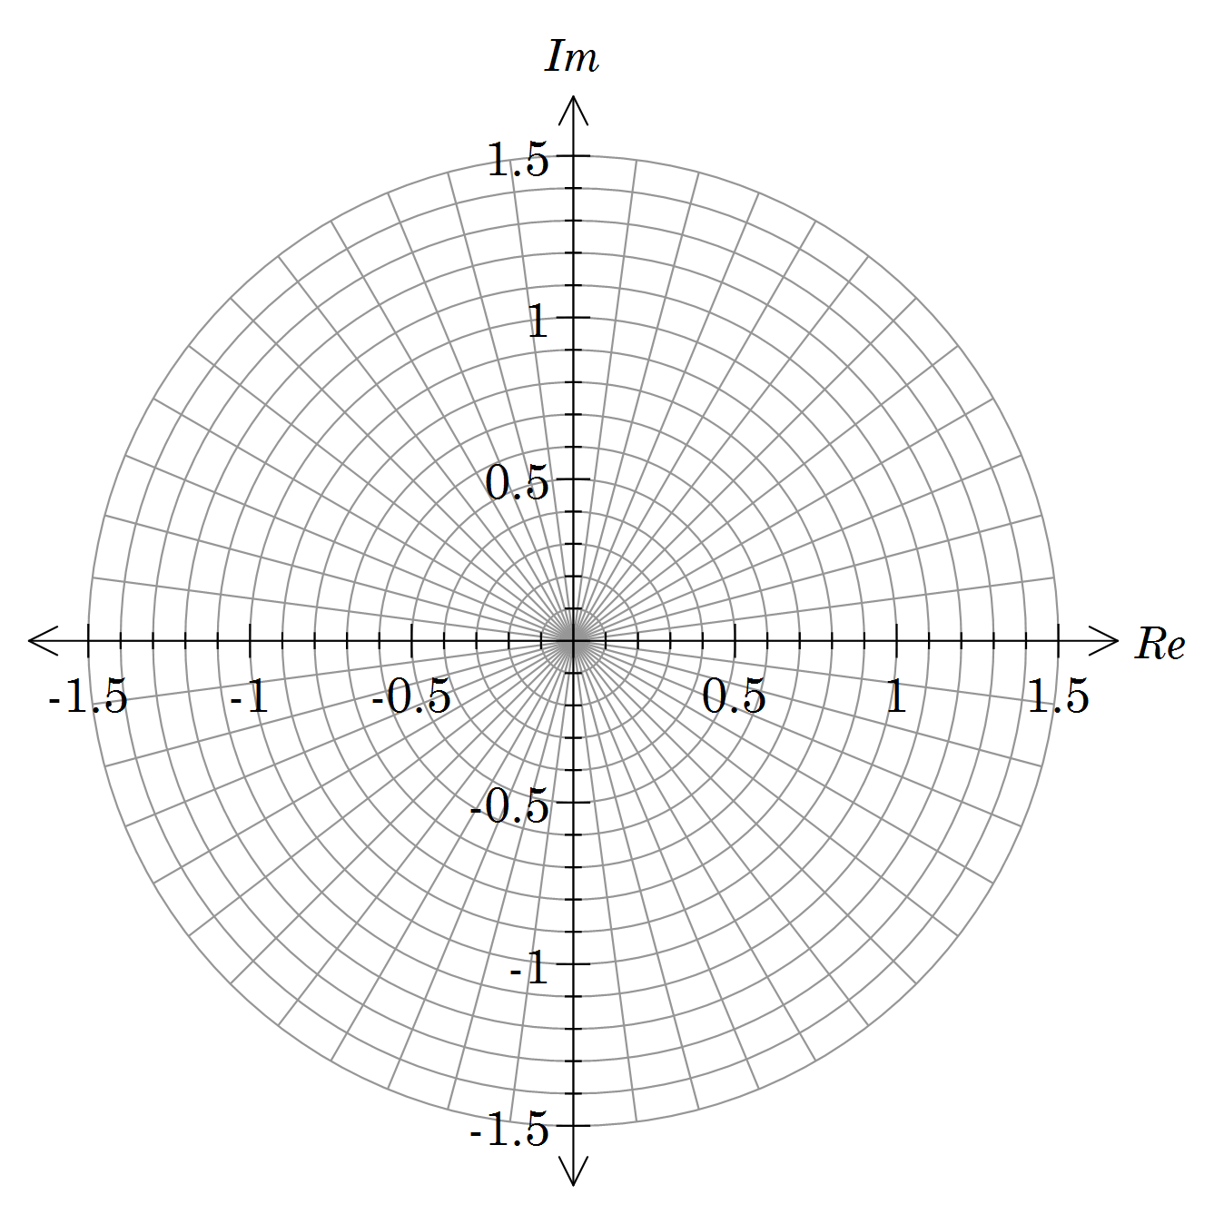

[4]

e) If represents the n^{th} solution to the equation in d) moving anticlockwise around the Argand diagram, explain the geometric meaning of and determine its value.

[3]

  - [8 marks]

- Sketch neatly the locus of z where , then determine the Cartesian equation of the resulting sketch.

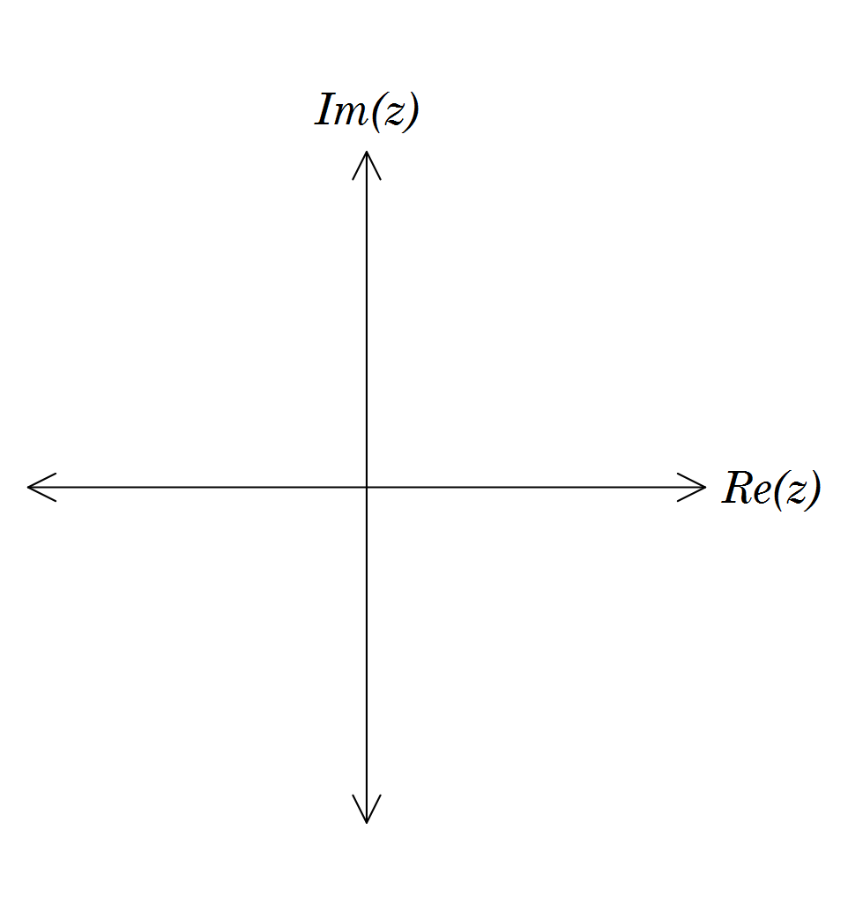

[3]

- Write an inequality that describes the locus of z shown below.
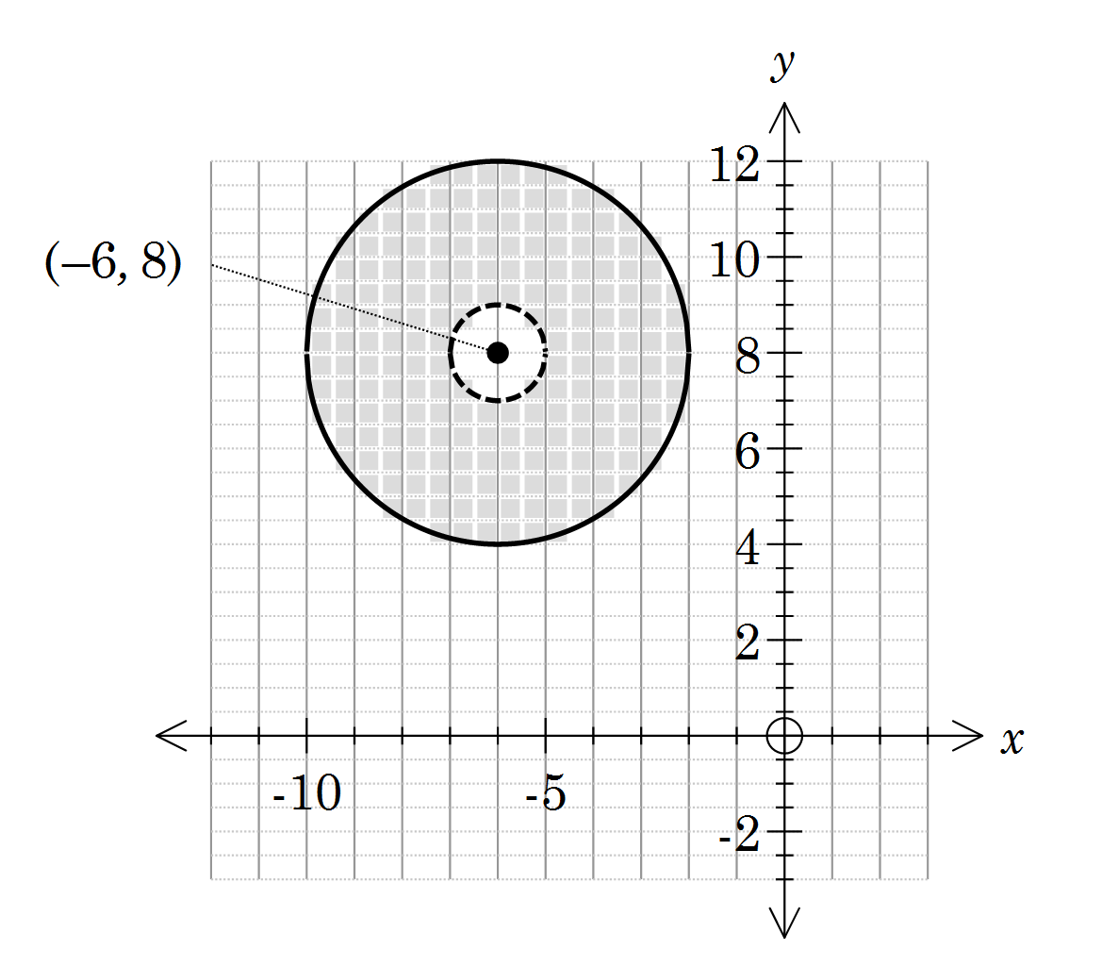

[3]
- For the locus shown in b) determine the minimum value of .

[7 marks]

Sketch the region in the Argand diagram below that simultaneously satisfies the inequalities:
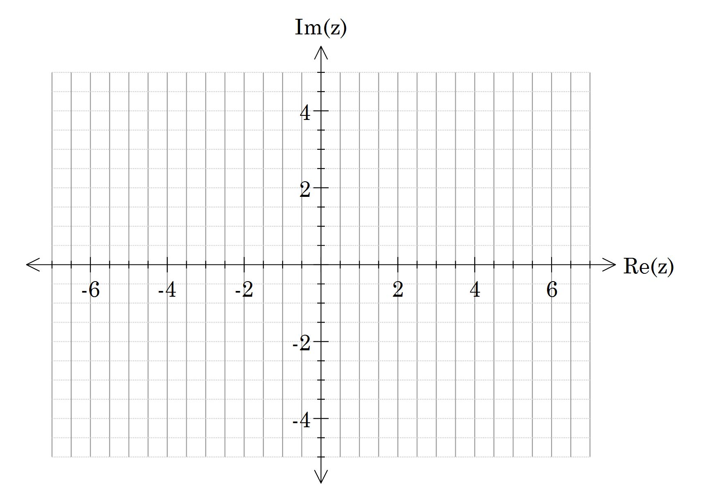

[5]

For , prove that

[2]

